Implementation of calories burnt prediction system using machine learning

A Mini Project-II Report submitted
in partial fulfillment of the requirements
for the award of the degree of

BACHELOR OF TECHNOLOGY

In

COMPUTER SCIENCE & ENGINEERING

By

Puppala Hema Sri – 19B01A05D8
Maddula Srujana – 19B01A05G4
Yannam Satya Amrutha – 19B01A05I9
Pasupuleti Bala Satya Sri – 20B05A0514

Under the esteemed guidance of

Dr.Dharmaiah Devarapalli ,ph.D.
Professor.



DEPARTMENT OF COMPUTER SCIENCE & ENGINEERING
SHRI VISHNU ENGINEERING COLLEGE FOR WOMEN(A)
(Approved by AICTE, Accredited by NBA & NAAC, Affiliated to JNTU Kakinada)
BHIMAVARAM – 534202
2021 – 2022

SHRI VISHNU ENGINEERING COLLEGE FOR WOMEN (A)
(Approved by AICTE, Accredited by NBA & NAAC, Affiliated to JNTU Kakinada)
BHIMAVARAM – 534 202

DEPARTMENT OF COMPUTER SCIENCE & ENGINEERING

CERTIFICATE

This is to certify that the Mini Project-II entitled “calories burnt prediction system”, is being submitted by Puppala.Hema Sri, Maddula.Srujana, Yannam.Satya Amrutha, Pasupuleti Bala Satya Sri bearing the Regd. No. 19B01A05D8, 19B01A05G4, 19B01A05I9, 20B05A0514 in partial fulfillment of the requirements for the award of the degree of “Bachelor of Technology in Computer Science & Engineering” is a record of bonafide work carried out by her under my guidance and supervision during the academic year 2021 – 2022 and it has been found worthy of acceptance according to the requirements of the university.

Internal Guide Head of the Department

ACKNOWLEDGEMENT
The satisfaction and euphoria that accompany the successful completion of any task would be impossible without the mention of the people who made it possible, whose constant guidance and encouragement crowned our efforts with success.

I have great pleasure in expressing my deep sense of gratitude to Dr. K.V. Vishnu Raju, Chairman of Shri Vishnu Educational Institutions for providing necessary infrastructure and creating good environment.

I take this opportunity to express my profound gratitude to Dr. G. Srinivasa Rao, Principal and Dr. P. Srinivasa Raju, Vice-principal of SVECW for their constant support and encouragement.

I would also like to thank Dr. P. Kiran Sree, Professor and Head of the Department of Computer Science and Engineering, for his constant support.

I am grateful to Dr. P. Kiran Sree (HOD), Mr. P. Raju (Project Co-Ordinator) and Dr.Dharmaiah Devarapalli (Project Guide) - PRC Members for their unfailing encouragement and suggestions, given to me in the course of my project work.

I express my gratitude to Dr.Dharmaiah Devarapalli , Professor, my project guide, for constantly monitoring the development of the project and setting up precise deadlines. Her valuable suggestions were the motivating factors in completing the work.
Finally, a note of thanks to the teaching and non-teaching staff of Dept of Computer Science and Engineering, for their cooperation extended to me, and my friends, who helped me directly or indirectly in the course of the project work.
Puppala Hema Sri– 19B01A05D8
Srujana Maddula– 19B01A05G4
Yannam Satya Amrutha–19B01A05I9
Pasupuleti Bala Satya Sri– 20B05A0514

ABSTRACT

Now a days, people are more conscious of their health. Exercise is a booming word these days. Many are making it as a part of their daily routine. To be honest, we humans are always interested in outcomes rather than the process so we came up with a web application to predict the calories burnt in an individual when they exercise. This is a machine learning model deployed as a web application that predicts the calories burnt in an individual using some necessary features and input parameters.

When building any machine learning model, domain knowledge is crucial. So, let us see some insights on the main features that predict our target variable which are calories in this case. One of the vital features to consider is heart rate because when a person consumes carbohydrates, these are converted to energy using oxygen while exercising. As oxygen consumption keeps on increasing, the heart too fluctuates, possibly in the upper curve. This is why we take heart rate as an important feature. The duration of exercise a person practiced is also a significant parameter to this case study as the duration is more, the calories burnt also increase rapidly.

Other important parameters to consider in this project are body temperature, height of the person and weight of that individual as these also play a major role in calories detection.

Contents

S.No. Topic Page No
- Introduction ………………… 1
- System Analysis ………………… 2
2.1Proposed System ………………… 2
2.2 Feasibility Study ………………… 2
- System Requirements Specification ………………… 3
  - Software Requirements ………………… 3
  - Hardware Requirements ………………… 3
  - Functional Requirements ………………… 3
- System Design ………………… 4
  - Introduction ………………… 5
  - UML Diagrams ………………… 6
- System Implementation ………………… 11
  - Introduction ………………… 11
  - Project Modules ………………… 14
5.3 Screens ………………… 15
- System Testing ………………… 16
  - Introduction ………………… 16
  - Testing Methods ………………… 17
6.3 Test Cases ………………… 18
- Conclusion ………………… 20
- Bibliography ………………… 20
9. Appendix ………………… 21
  - Introduction to Machine Learning ………………… 21
  - Introduction to Flask ………………… 22

1.INTRODUCTION

Calories Burnt Prediction System:

A calorie is a unit of measurement for both energy consumption and energy storage. Kilocalories are the units of measurement for both food (calories consumed) and exercise (calories burnt) (kcal).

At sea level, one kilocalorie equals the amount of heat required to increase the temperature of one kilogramme of water by one degree Celsius. As heat energy is measured in research labs, one kilocalorie equals 4186.8 joules and 1000 calories (small calories).Calories in food provide energy in the form of heat to our bodies, allowing them to function. This means that we must consume a certain number of calories just to live. However, if we consume too many calories, we risk gaining weight.

As a result, there is a requirement to burn. Calories, we do exercises and other things to burn calories. To determine the number of calories burned, the calories burned prediction system will forecast calories based on some data.

The body mass index (BMI) is a number calculated from a person's weight and height. The BMI is calculated by dividing the body mass by the square of the body height, and is represented in kilogrammes per square metre (kg/m2), with mass in kilogrammes and height in metres.

The BMI is a simple formula that uses tissue mass (muscle, fat, and bone) and height to classify a person as underweight, normal weight, overweight, or obese. Underweight (under 18.5 kg/m2), normal weight (18.5 to 24.9), overweight (25 to 29.9), and obese are the four major adult BMI classifications (30 or more). [1] The BMI has limits when used to forecast an individual's health rather than as a statistical assessment for groups.

2.SYSTEM ANALYSIS

2.1 PROPOSED SYSTEM

- Our system is a web app that takes an individual weight ,height , heart rate,body temperature, exercise duration as input .
- Using regression algorithm and some necessary input parameters, Our model will predict the calories burnt in an individual when they exercise and also by considering weight and height our app will display the BMI value and categorizes the user to the relevant class.

2.2 FEASIBILITY STUDY

This project was created with the understanding that people are becoming more health-conscious, and they are doing a variety of things to maintain good health. These days, "exercise" is a buzzword. Many people are incorporating it into their regular regimen. The main idea of our project is , we developed a web application that can estimate how many calories a person would burn while exercising. We created a machine learning model and implemented it as a web application that estimates an individual's calorie burn based on a set of attributes and input parameters.

IDENTIFICATION OF MAIN PROBLEM AND POSSIBLE SOLUTIONS :

People are generally embarrassed to admit that they are overweight when others are watching them, thus our product enables these people to keep their weight troubles hidden, rather than having it revealed to others that they are overweight. We designed this application using an estimated BMI scale.

3.SYSTEM REQUIREMENTS & SPECIFICATIONS

3.1 HARDWARE REQUIREMENTS :
Processor : intel core i3(minimum) and above
Hard Disk : 2GB(minimum)
Input Device : Keyboard and Mouse
Output Device : Monitor or PC

3.2 SOFTWARE REQUIREMENTS
Operating System : Windows 10
Web Technologies : HTML,CSS
Programming Language : Python
Editor : Visual Studio Code

3.3 FUNCTIONAL REQUIREMENTS
A Functional requirement defines a function of a system or its component. A function is described as a set of inputs, the behavior, and outputs. Functional requirements may be calculations, technical details, data manipulation and processing and other specific functionality that define what a system is supposed to accomplish
- Functional Requirements concerns with the specific functions delivered by the system.
- The functional requirements of the system should be both complete and consistent.
- Completeness means that all the services required by the user should be defined.
- Consistency means that requirements should not have any contradictory definitions.

The requirements are usually described in an abstract way. However, functional
system requirements describe the system function in detail, its inputs and outputs,
exceptions and so on.

4.SYSTEM DESIGN

4.1 INTRODUCTION

System Design can be best understood from design goals and system architecture. Each
and every system has its own system goals and significance.

DESIGN GOALS:
Few system design goals are as follows:
    - Performance requirement: All data entered shall be up to mark and no flaws shall be there for the performance to be 100%.
    - Platform constraints: The main target is to generate an intelligent system to predict the disease.
    - Accuracy and Precision: Requirements are accuracy and precision of the
data given as input as well as produced as output.
    - Modifiability: Requirements about the effort required to make changes in the software. (person- months).
    - Portability: Since mobile phone is handy so it is portable and can be carried and used whenever required.
    - Reliability: Requirements about how often the software fails. The definition of a failure must be clear. Also, don't confuse reliability with availability which is quite a different kind of requirement. Be sure to specify the consequences of software failure, how to protect from failure, a strategy for error Prediction, and a strategy for correction.
    - Security: One or more requirements about protection of your system and its data.
    - Usability: Requirements about how difficult it will be to learn and operate the system. The requirements are often expressed in learning time or similar metrics.

SYSTEM ARCHITECTURE:
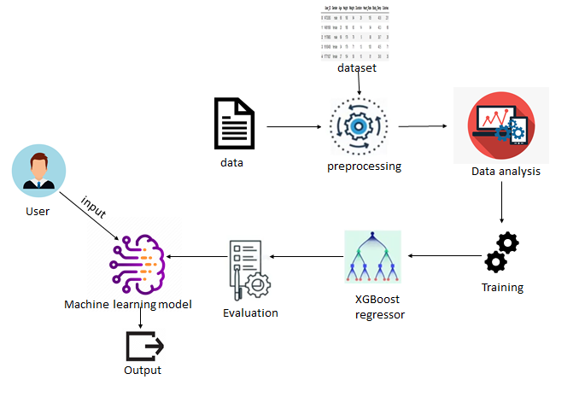
Figure 4.1.1 System Architecture for Calories burnt prediction system

In general, machine learning involves training of algorithms accordingly. This training is done in three ways of learning approaches. Supervised Learning, Unsupervised Learning and Reinforcement Learning.

The machine learning algorithm considered to implement this project is of supervised
Learning category. In the case of supervised machine learning, the algorithm is to be trained under supervision. The supervisor is responsible for making a training dataset and respective outputs. The training dataset and the desired outputs are processed and given to the algorithm. The trained algorithm is tested through some random inputs given by the supervisor. If the prediction made is accurate then algorithm is deployed or else the algorithm gets back into training phase. The algorithm is supervised until it reaches an expected level of performance. Once it reaches, the algorithm would be deployed.

Most probably, supervised machine learning algorithms are used in mapping models. Few popular supervised machine learning algorithms are Decision Tree, Support Vector Machines, Linear Regression and Random Forest.

4.2 UML DIAGRAMS
Use Case Diagram: It represents the functionality of a system by utilizing actors and use cases. It encapsulates the functional requirement of a system and its association with actors. It portrays the use case view of a system.
Following are the purposes of a use case diagram given below:
- It gathers the system's needs.
- It depicts the external view of the system.
- It recognizes the internal as well as external factors that influence the system.
- It represents the interaction between the actors.

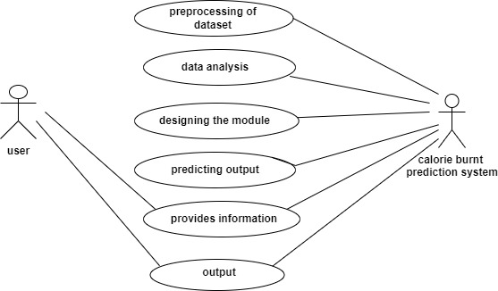
Figure 4.2.1 ​ Use Case diagram for Disease Prediction Based on Symptoms

Class Diagram: Class diagrams are one of the most widely used diagrams. It is the backbone of all the object-oriented software systems. It depicts the static structure of the system. It displays the system's class, attributes, and methods. It is helpful in recognizing the relation between different objects as well as classes.
Following are the purposes of a class diagram given below:
- It analyses and designs a static view of an application.
- It describes the major responsibilities of a system.
- It is a base for component and deployment diagrams.
- It incorporates forward and reverse engineering.
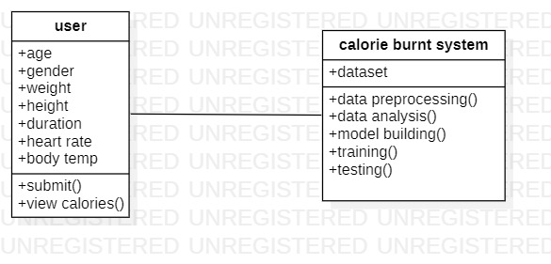
Figure 4.2.2 ​ Class diagram for Implementation of calories burnt prediction system

Activity Diagram: It models the flow of control from one activity to the other. With the help of an activity diagram, we can model sequential and concurrent activities. It visually depicts the workflow as well as what causes an event to occur.
Following are the purposes of an activity diagram given below:
- models processes and workflow
- envisions the dynamic behavior of the system
- deals with flow that can be sequential, branched, or concurrent
- has fork and join elements to show special flow
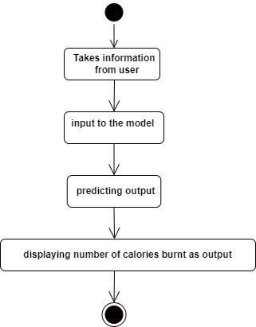
Figure 4.2.4 ​ Activity diagram for Implementation of calories burnt prediction system

Sequence Diagram: It shows the interactions between the objects in terms of messages exchanged over time. It delineates in what order and how the object functions are in a system.
Following are the purposes of a sequence diagram given below:
- To model high-level interaction among active objects within a system.
- To model interaction among objects inside a collaboration realizing a use case.
- It either model generic interactions or some certain instances of interaction.

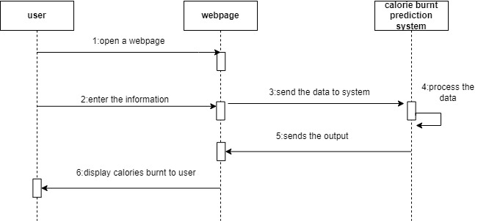
Figure 4.2.5 ​ Sequence Diagram for Implementation of calories burnt prediction system

Component Diagram: It portrays the organization of the physical components within the system. It is used for modeling execution details. It determines whether the desired functional requirements have been considered by the planned development or not, as it depicts the structural relationships between the elements of a software system.
Following are the purposes of a component diagram given below:
- It portrays the components of a system at the runtime.
- It is helpful in testing a system.
- It envisions the links between several connections.

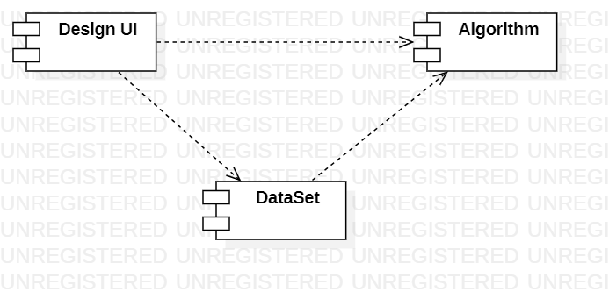
Figure 4.2.6 ​ Component for Implementation of calories burnt prediction system

5.SYSTEM IMPLEMENTATION
5.1 INTRODUCTION
Random forest is a Supervised Machine Learning Algorithm that is used widely in Classification and Regression problems. It builds decision trees on different samples and takes their majority vote for classification and average in case of regression. One of the most important features of the Random Forest Algorithm is that it can handle the data set containing continuous variables as in the case of regression and categorical variables as in the case of classification. It performs better results for classification problems.
Step 1: Pick at random k data points from the training set.
Step 2: Build the decision Tree associated with this K data point.
Step 3: Choose the number N tree of trees you want to build and repeat STEPS 1 & 2.
Step 4: For a new data point, make each one of our N tree trees predict the value of Y for the data point in question and assign the new data point the average across all of the predicted Y values.

Source code:
import numpy as np
import pandas as pd
import matplotlib.pyplot as plt
import seaborn as sns
from sklearn.model_selection import train_test_split
from sklearn.ensemble import RandomForestRegressor
from sklearn import metrics
import pickle

calories = pd.read_csv('calories.csv')
exercise_data = pd.read_csv('exercise.csv')
calories_data = pd.concat([exercise_data, calories['Calories']], axis=1)

calories_data["Weight"] = calories_data["Weight"]*0.453592
calories_data["Height"] = calories_data["Height"]*0.01

calories_data.replace({"Gender":{'male':0,'female':1}}, inplace=True)
X = calories_data.drop(columns=['User_ID','Calories'], axis=1)
Y = calories_data['Calories']

X_train, X_test, Y_train, Y_test = train_test_split(X, Y, test_size=0.2, random_state=2)
print(X.shape, X_train.shape, X_test.shape)

from sklearn.linear_model import LinearRegression
from sklearn.tree import DecisionTreeRegressor
from sklearn.neighbors import KNeighborsRegressor
from sklearn.model_selection import train_test_split
from sklearn.metrics import r2_score, mean_absolute_error, mean_squared_error

dt = DecisionTreeRegressor()
knn = KNeighborsRegressor()
lr = LinearRegression()

x_train, x_test, y_train, y_test = train_test_split(X,Y,test_size=0.3, random_state=42)
for i in [dt, knn, lr]:
i.fit(x_train,y_train)
pred = i.predict(x_test)
test_score = r2_score(y_test, pred)
train_score = r2_score(y_train, i.predict(x_train))
print(i)
print("R2 score is ", r2_score(y_test, pred))
print("R2 score for train is ", r2_score(y_train, i.predict(x_train)))
print()
plt.figure(figsize=(6,6))
plt.scatter(y_test, i.predict(x_test),c="crimson")
plt.show()

from sklearn.ensemble import RandomForestRegressor, AdaBoostRegressor, GradientBoostingRegressor

rfr = RandomForestRegressor()
ad = AdaBoostRegressor()
gd = GradientBoostingRegressor()

x_train, x_test, y_train, y_test = train_test_split(X,Y, test_size = 0.3,random_state = 100)
for i in [rfr,ad,gd]:
i.fit(x_train,y_train)
pred = i.predict(x_test)
test_score = r2_score(y_test,pred)
train_score = r2_score(y_train,i.predict(x_train))
if abs(train_score - test_score) <= 0.2:
print(i)
print('R2 score is ',r2_score(y_test,pred))
print('R2 for train data',r2_score(y_train,i.predict(x_train)))
print('Mean absolute error is ',mean_absolute_error(y_test,pred))
print('Mean squared error is ',mean_squared_error(y_test,pred))
print('Root mean squared error is ',(mean_squared_error(y_test,pred,squared = False)))
print()
plt.figure(figsize=(6,6))
plt.scatter(y_test, i.predict(x_test),c="crimson")
plt.show()

model = RandomForestRegressor(n_estimators=10)
model.fit(X_train, Y_train)

x_train, x_test, y_train, y_test = train_test_split(X,Y,test_size=0.3)
model = RandomForestRegressor(n_estimators=10)
model.fit(x_train,y_train)
pred = model.predict(x_test)
print("R2 score", r2_score(y_test,pred))
print('R2 for train data',r2_score(y_train,i.predict(x_train)))

input_data = (0,68,190.0,94.0,29.0,105.0,40.8)
input_data_as_array = np.asarray(input_data)
input_data_reshape = input_data_as_array.reshape(1,-1)
prediction = model.predict(input_data_reshape)
print(prediction)

def get_BMI(weight, height):
return weight/(height*height)

def original_BMI(BMI):
if BMI < 18.5:
return "Underweight"
elif BMI < 24.9:
return "Normalweight. Good job, keep going."
elif BMI < 29.9:
return "Overweight"
elif BMI < 34.9:
return "Obesity class 1"
elif BMI < 39.9:
return "Obesity class 2"
else:
return "Obesity class 3"

pickle.dump(model, open("model.pkl", "wb"))

5.2 PROJECT MODULES
USER MODULE
- This module deals with the user entry into the prediction system. This takes in the details such as name.
- It is also responsible for taking in the symptoms from the user into the system.
- These symptoms are taken-in, through the drop-down list.
- The user just needs to select a choice from the drop-down list.
DATASET MODULE
- This module’s main focus is on collecting raw data from various hospitals and gathering already existing datasets.
- Once the needed raw data and datasets are collected, they would be arranged and made into a single dataset.
- The raw data gathered is appended to the existing dataset which is in the form of CSV file.
- CSV – Comma Separated Value, the file extension would be .csv
- This dataset obtained would be verified and finalised such that there would be no duplicates or incorrect data.

ML ALGO-TRAINING MODULE
- The dataset that’s finalised in the previous module is used to train the algorithm.
- Algorithm is first trained and then is tested with model inputs .
- The algorithm on receiving the model inputs must predict the output accurately.
- If the output isn’t accurate then the algorithm goes back into training phase as before. This process repeats till the algorithm is trained to a level of performance that it produces an accurate result.
- Once the algorithm is trained and has reached it’s expected performance level it can be deployed.
INTERFACE MODULE
- In this module all the interface designing responsibilities and issues with it would be dealt.
- According to the interface related goals the designing is done at last after the whole algorithm is deployed.
5.3 SCREENS
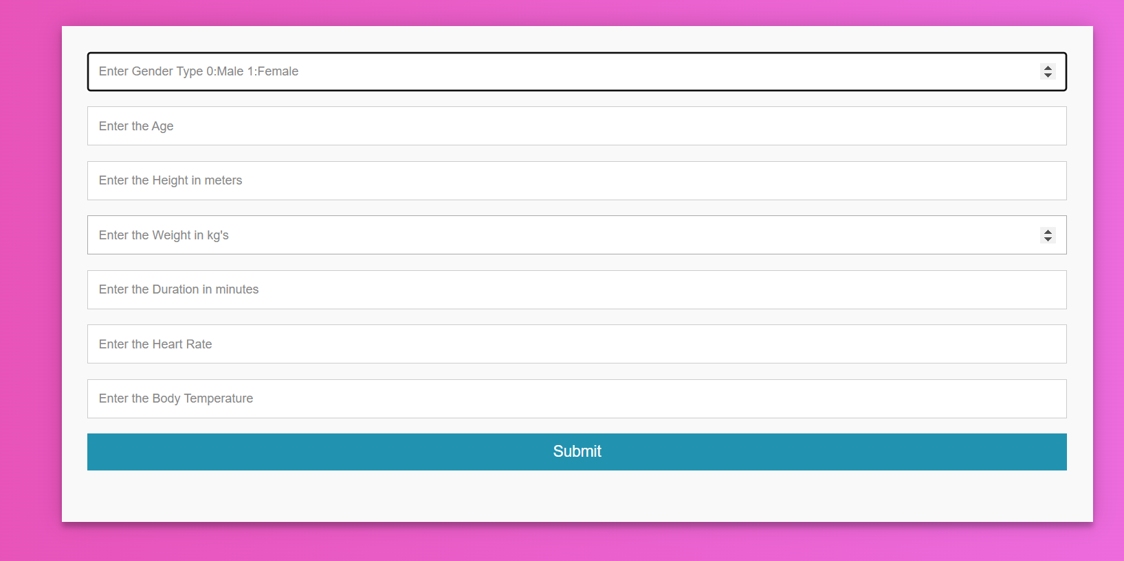
5.3.1 Main page
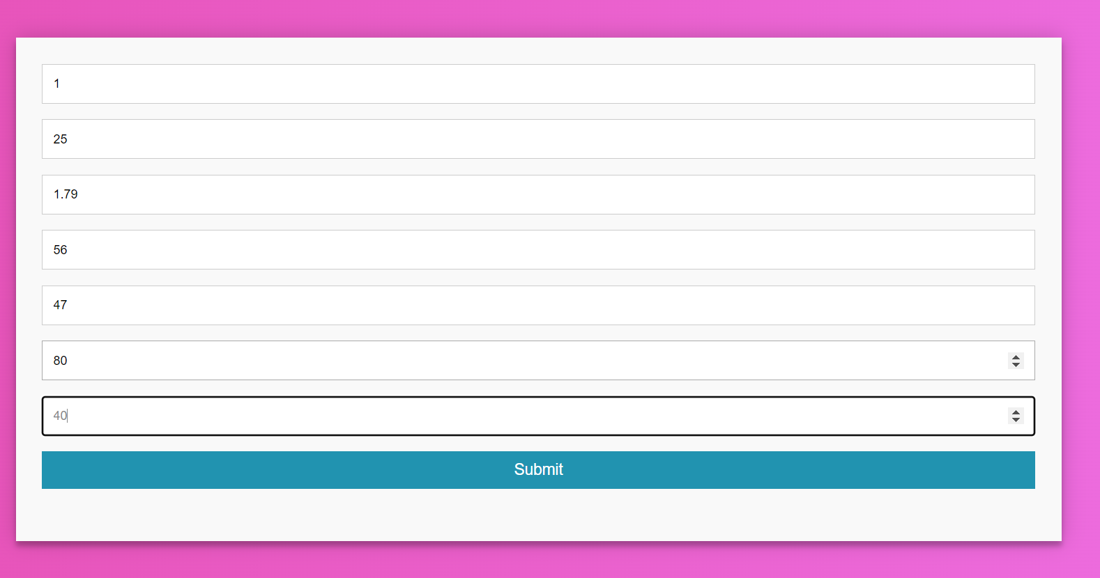
5.3.2 Page after entering values.

6.TESTING
6.1 INTRODUCTION
In a software development project, errors can be introduced at any stage during development. Though errors are detected after each phase by techniques like inspections, some errors remain undetected. Ultimately, these remaining errors are reflected in the code. There are two types of approaches for identifying defects in the software—static and dynamic. The basic purpose of testing is to increase the confidence in the functioning of Software under test (SUT). Clearly, the effectiveness and efficiency of testing depends critically on the test cases selected.
Different levels of testing are used in the testing process, each level of testing aims to test different aspects of the system. The basic levels are unit testing, integration testing, and validation testing. These different levels of testing attempt to detect different types of faults.
6.2 TESTING METHODS
WHITE BOX TESTING
White Box Testing is a testing in which in which the software tester has knowledge of the inner workings, structure and language of the software, or at least its purpose. It is purpose. It is used to test areas that cannot be reached from a black box level.
BLACK BOX TESTING
Black Box Testing is testing the software without any knowledge of the inner workings, structure or language of the module being tested. Black box tests, as most other kinds of tests, must be written from a definitive source document, such as specification or requirements document, such as specification or requirements document.
UNIT TESTING
Unit testing is usually conducted as part of a combined code and unit test phase of the software lifecycle, although it is not uncommon for coding and unit testing to be conducted as two distinct phases.
INTEGRATION TESTING
Software integration testing is the incremental integration testing of two or more integrated software components on a single platform to produce failures caused by interface defects.
VALIDATION TESTING
The process of evaluating software during the development process or at the end of the development process to determine whether it satisfies specified business requirements.
Validation Testing ensures that the product actually meets the client’s needs. It can also be defined as to demonstrate that the product fulfils its intended use when deployed on appropriate environment.

6.3 TEST CASES
Main screen
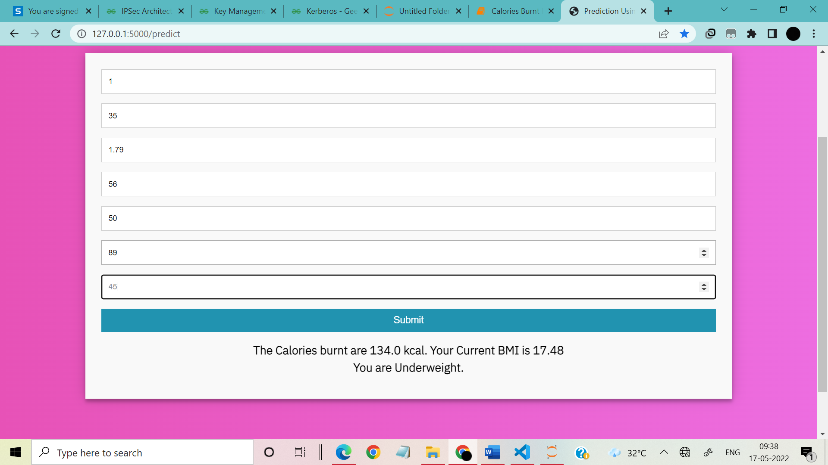
Underweight is predicted.
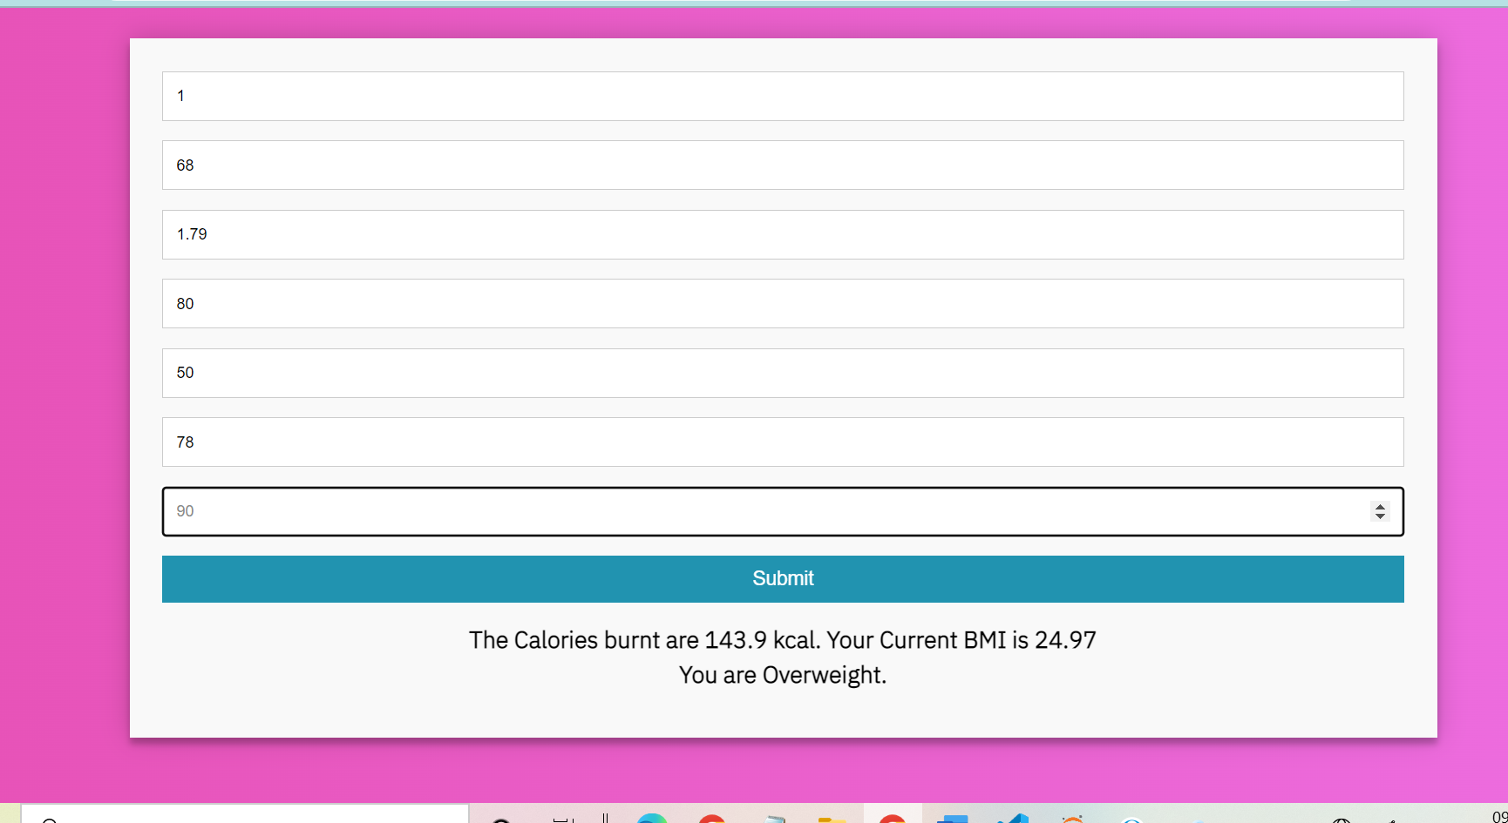
Overweight is predicted.

7. CONCLUSION
It’s a web application to predict the calories burnt in an individual when they exercise. This is a machine learning model deployed as a web application that predicts the calories burnt in an individual using some necessary features and input parameters.
Based on the user's inputs, we attempted to provide the most accurate amount of calories burned by an individual, as well as the BMI . Based on the BMI ,we predict the group to which the person belongs such as normal weight, underweight, obesity etc.. we also assist them in maintaining a good diet and maintain consistency in doing exercises in order to maintain good health.

8.BIBLIOGRAPHY
DISEASES DATASET
https://www.kaggle.com/fmendes/fmendesdat263xdemos
FlASK TUTORIAL
https://flask.palletsprojects.com/en/2.1.x/
MACHINE LEARNING INTRODUCTION
Machine Learning - GeeksforGeeks
RANDOM FOREST ALGORITHM
https://www.analyticsvidhya.com/blog/2021/06/understanding-random-forest/

9.APPENDIX
9.1 Introduction to MACHINE LEARNING
Machine learning is a subset of Artificial Intelligence. Machine Learning consists of statistical methods that enable machines to improve with experience. It focuses mainly on the designing of systems, thereby allowing them to learn and make predictions based on experience.

Unsupervised Learning is a machine learning technique in which the users do not need to supervise the model. Instead, it allows the model to work on its own to discover patterns and information that was previously undetected. It mainly deals with the unlabeled data.

Supervised learning is the types of machine learning in which machines are trained using well "labelled" training data, and on basis of that data, machines predict the output. The labelled data means some input data is already tagged with the correct output.
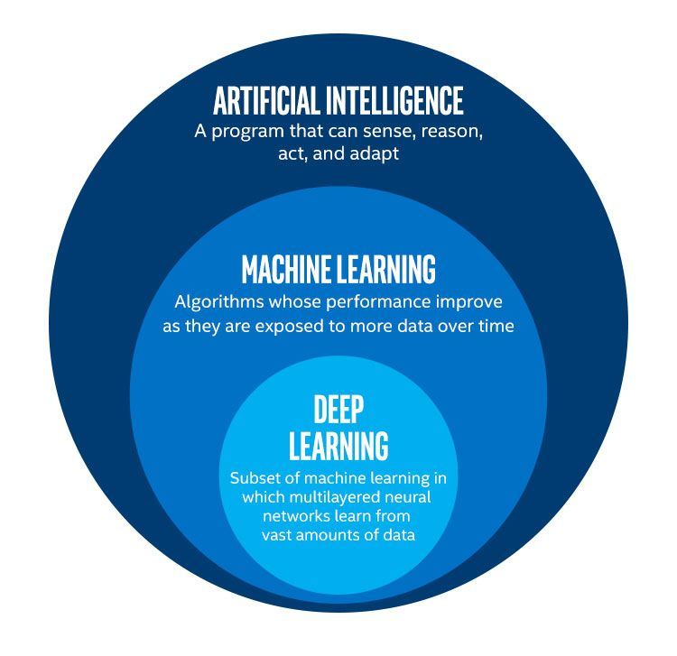
Figure 9.1.1 Technologies chart

Reinforcement learning is an area of Machine Learning. It is about taking suitable action to maximize reward in a particular situation. It is employed by various software and machines to find the best possible behavior or path it should take in a specific situation.

9.2 Introduction to Flask:
Flask is an API of Python that allows us to build up web-applications. It was developed by Armin Ronacher. Flask’s framework is more explicit than Django’s framework and is also easier to learn because it has less base code to implement a simple web-Application.
A Web-Application Framework or Web Framework is the collection of modules and libraries that helps the developer to write applications without writing the low-level codes such as protocols, thread management, etc. Flask is based on WSGI(Web Server Gateway Interface) toolkit and Jinja2 template engine.
Nowadays, the web frameworks provide routing technique so that user can remember the URLs. It is useful to access the web page directly without navigating from the Home page. It is done through the following route() decorator, to bind the URL to a function.

